

Cloud Computing Lab 12

Submitted To: Sir Waqas Saleem
Submitted By: Hamail Fatima
Roll No: 2023-BSE-023
Section: 5(A)

Course Name: Cloud Computing

Lab 12 repo link: https://github.com/Hamail-maker/CC_Hamail-Fatima_2023-BSE-023_Lab12.git

Lab # 12

Task 0 Lab Setup (Codespace & GH CLI)

All actions below should be executed inside the Codespace shell.
Create Codespace & connect:
# create or open codespace via GH CLI (example)
gh repo create CC_<YourName>_<YourRollNumber>/Lab12 --public
gh codespace create --repo <user_name>/Lab12
gh codespace list
gh codespace ssh -c <your_codespace_name>

- Save screenshot as: task0_codespace_create_and_list.png — output showing repo creation/codespace list.

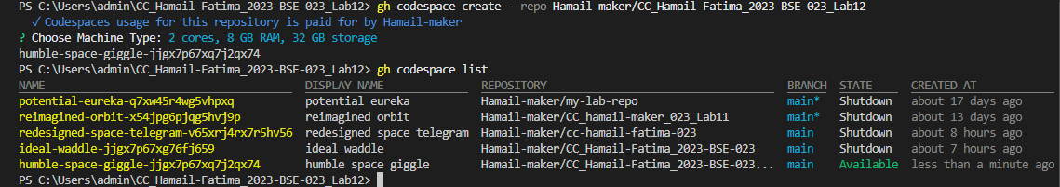

- Save screenshot as: task0_codespace_ssh_connected.png — terminal inside the Codespace shell after ssh.

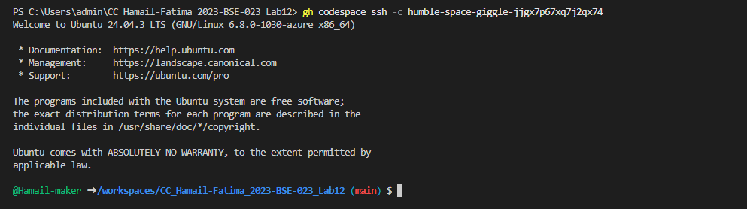

Task 1 — Organize Terraform code into separate files
In this task, you will split a monolithic Terraform configuration into separate, well-organized files following best practices.
- Create the initial project structure:
mkdir -p ~/Lab12
cd ~/Lab12
- Save screenshot as: task1_project_directory.png — terminal showing directory creation.

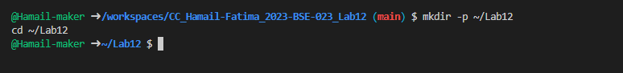

- Create all required files:
touch main.tf variables.tf outputs.tf locals.tf terraform.tfvars entry-script.sh

- Save screenshot as: task1_files_created.png — terminal showing all files created (use ls -la).

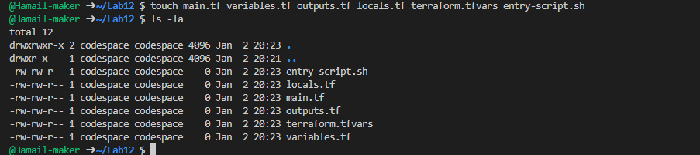

- Create variables.tf with the following content:
variable "vpc_cidr_block" {}
variable "subnet_cidr_block" {}
variable "availability_zone" {}
variable "env_prefix" {}
variable "instance_type" {}
variable "public_key" {}
variable "private_key" {}
- Save screenshot as: task1_variables_tf.png — content of variables.tf file.

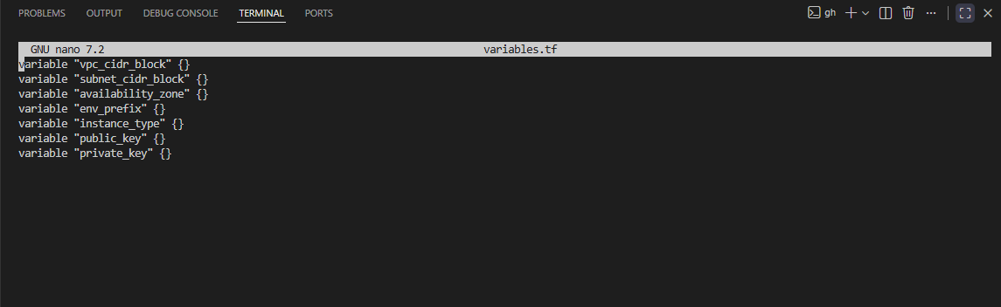

- Create outputs.tf with the following content:
output "aws_instance_public_ip" {
value = aws_instance.myapp-server.public_ip
}
- Save screenshot as: task1_outputs_tf.png — content of outputs.tf file.

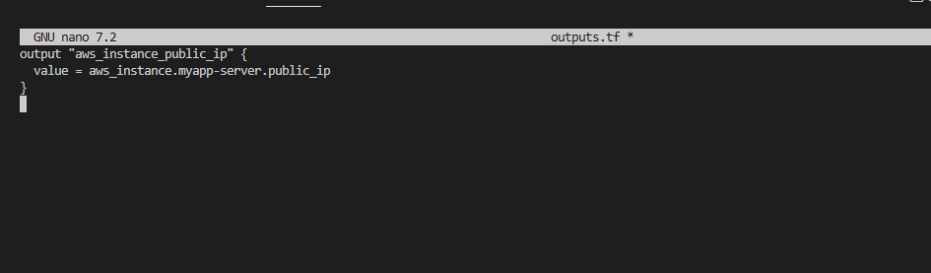

5.Create locals.tf with the following content:
locals {
my_ip = "${chomp(data.http.my_ip.response_body)}/32"
}

data "http" "my_ip" {
url = "https://icanhazip.com"
}
- Save screenshot as: task1_locals_tf.png — content of locals.tf file.

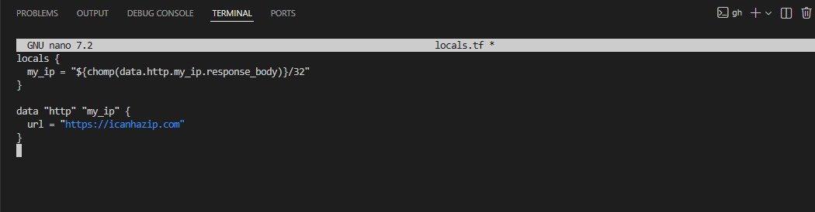

- Create terraform.tfvars with the following content:
vpc_cidr_block = "10.0.0.0/16"
subnet_cidr_block = "10.0.10.0/24"
availability_zone = "me-central-1a"
env_prefix = "dev"
instance_type = "t3.micro"
public_key = "~/.ssh/id_ed25519.pub"
private_key = "~/.ssh/id_ed25519"
- Save screenshot as: task1_terraform_tfvars. png — content of terraform.tfvars file.

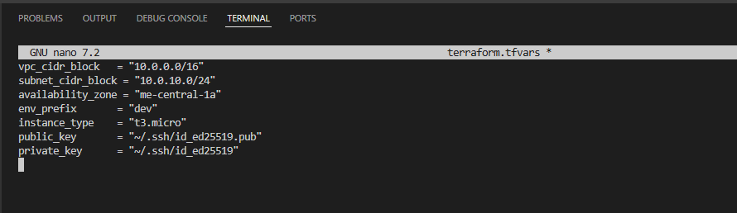

- Create main.tf with the following content:
provider "aws" {
shared_config_files = ["~/.aws/config"]
shared_credentials_files = ["~/.aws/credentials"]
}

resource "aws_vpc" "myapp_vpc" {
cidr_block = var.vpc_cidr_block
tags = {
Name = "${var.env_prefix}-vpc"
}
}

resource "aws_subnet" "myapp_subnet_1" {
vpc_id = aws_vpc.myapp_vpc.id
cidr_block = var.subnet_cidr_block
availability_zone = var.availability_zone
tags = {
Name = "${var.env_prefix}-subnet-1"
}
}

resource "aws_default_route_table" "main_rt" {
default_route_table_id = aws_vpc.myapp_vpc.default_route_table_id

route {
cidr_block = "0.0.0.0/0"
gateway_id = aws_internet_gateway.myapp_igw.id
}
tags = {
Name = "${var.env_prefix}-rt"
}
}

resource "aws_internet_gateway" "myapp_igw" {
vpc_id = aws_vpc.myapp_vpc.id
tags = {
Name = "${var.env_prefix}-igw"
}
}

resource "aws_default_security_group" "default_sg" {
vpc_id = aws_vpc.myapp_vpc.id

ingress {
from_port = 22
to_port = 22
protocol = "tcp"
cidr_blocks = [local.my_ip]
}
ingress {
from_port = 80
to_port = 80
protocol = "tcp"
cidr_blocks = ["0.0.0.0/0"]
}
egress {
from_port = 0
to_port = 0
protocol = "-1"
cidr_blocks = ["0.0.0.0/0"]
prefix_list_ids = []
}
tags = {
Name = "${var.env_prefix}-default-sg"
}
}

resource "aws_key_pair" "ssh-key" {
key_name = "serverkey"
public_key = file(var.public_key)
}

resource "aws_instance" "myapp-server" {
ami = "ami-05524d6658fcf35b6" # Amazon Linux 2023 Kernel 6.1 AMI
instance_type = var.instance_type
subnet_id = aws_subnet.myapp_subnet_1.id
security_groups = [aws_default_security_group.default_sg. id]
availability_zone = var.availability_zone
associate_public_ip_address = true
key_name = aws_key_pair.ssh-key. key_name

user_data = file("./entry-script.sh")

tags = {
Name = "${var.env_prefix}-ec2-instance"
}
}
- Save screenshot as: task1_main_tf.png — content of main.tf file.

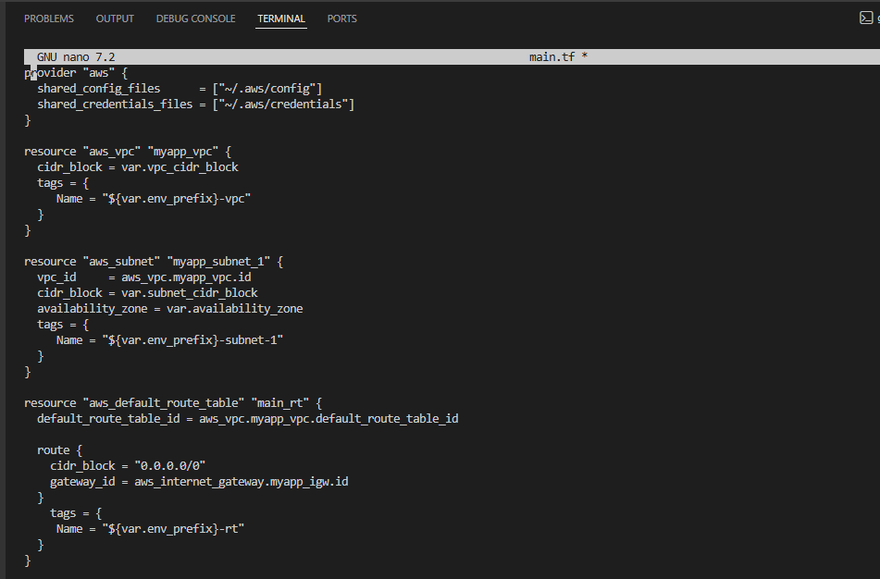

- Create entry-script.sh with the following content:
#!/bin/bash
set -e
yum update -y
yum install -y nginx
systemctl start nginx
systemctl enable nginx

- Save screenshot as: task1_entry_script.png — content of entry-script.sh file.

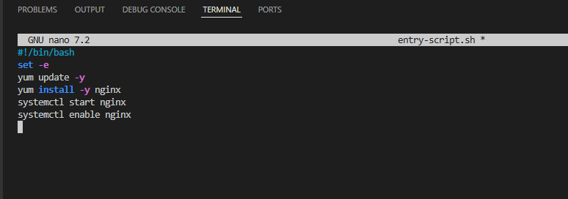

- Generate SSH key pair if not already exists:
ssh-keygen -t ed25519 -f ~/.ssh/id_ed25519 -N ""
- Save screenshot as: task1_ssh_keygen.png — terminal showing SSH key generation.

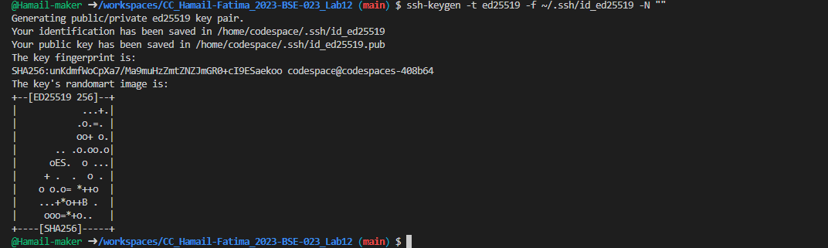

- Initialize Terraform:
terraform init
- Save screenshot as: task1_terraform_init.png — terraform init output.

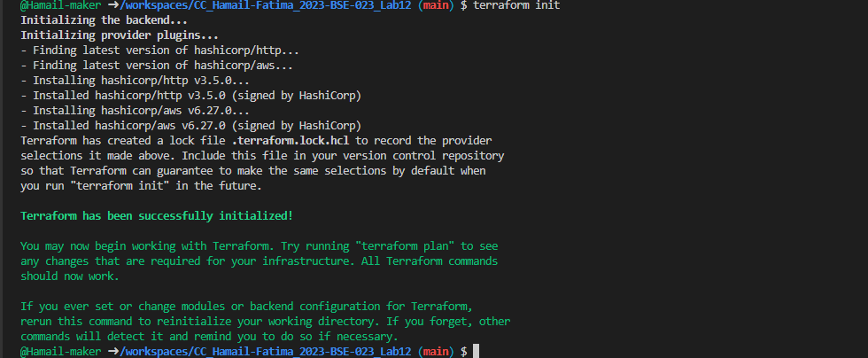

- Apply the configuration:

terraform apply -auto-approve
- Save screenshot as: task1_terraform_apply.png — terraform apply output showing resources created.

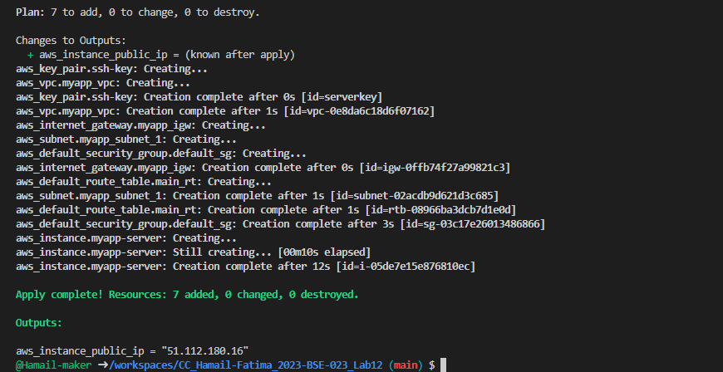

- Display the output:
terraform output

- Save screenshot as: task1_terraform_output.png — terraform output showing public IP.

- Test nginx in browser:
- Open browser and navigate to http://<public-ip>
- Save screenshot as: task1_nginx_browser.png — browser showing nginx default page.

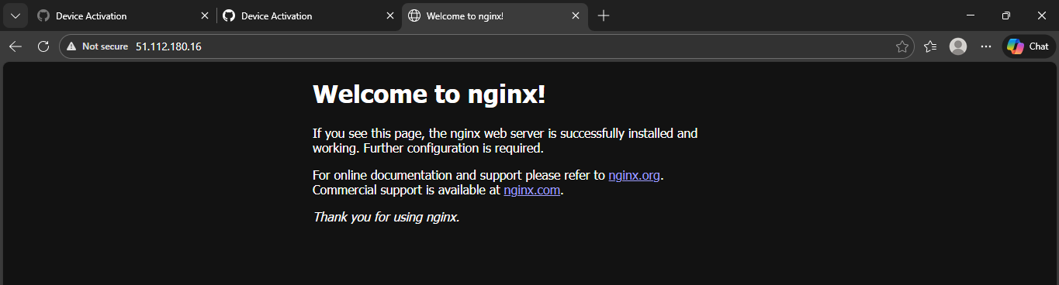

- Destroy resources:
terraform destroy
- Type yes when prompted for confirmation.
- Save screenshot as: task1_terraform_destroy.png — terraform destroy output.

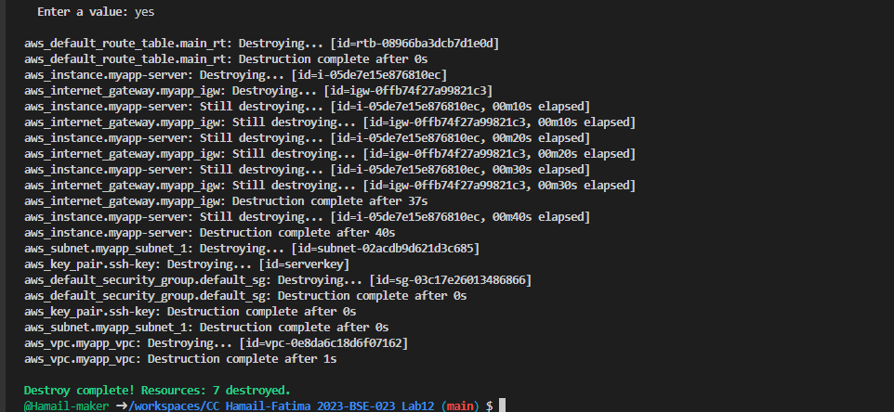

Task 2 — Use remote-exec provisioner
In this task, you will replace the user_data approach with the remote-exec provisioner to install and configure nginx.
- Modify the aws_instance resource in main.tf to use remote-exec provisioner:
Replace the user_data line with the following provisioner block:
resource "aws_instance" "myapp-server" {
ami = "ami-05524d6658fcf35b6"
instance_type = var.instance_type
subnet_id = aws_subnet.myapp_subnet_1.id
security_groups = [aws_default_security_group.default_sg.id]
availability_zone = var.availability_zone
associate_public_ip_address = true
key_name = aws_key_pair.ssh-key.key_name

connection {
type = "ssh"
user = "ec2-user"
private_key = file(var.private_key)
host = self.public_ip
}

provisioner "remote-exec" {
inline = [
"sudo yum update -y",
"sudo yum install -y nginx",
"sudo systemctl start nginx",
"sudo systemctl enable nginx"
]
}

tags = {
Name = "${var. env_prefix}-ec2-instance"
}
}
- Save screenshot as: task2_main_tf_remote_exec.png — main.tf showing remote-exec provisioner.

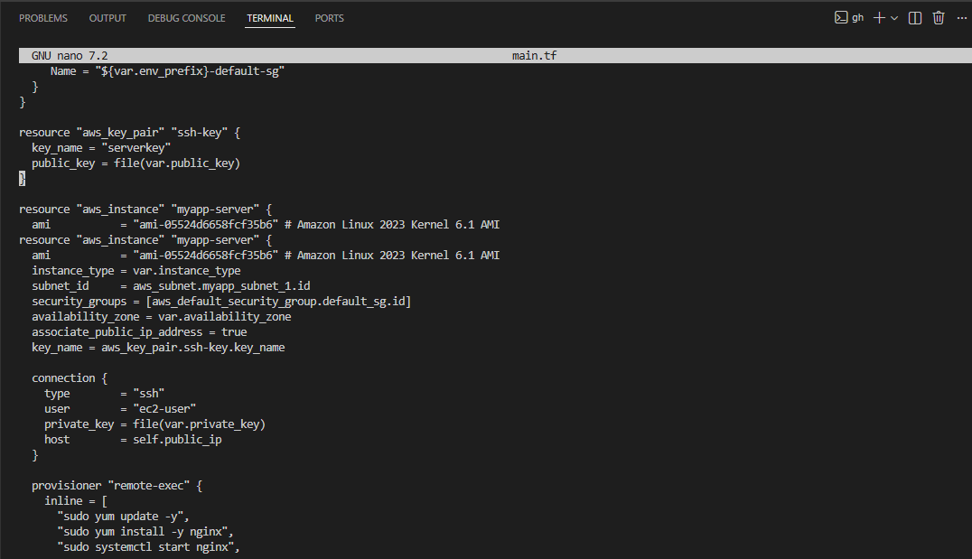

- Apply the configuration:
terraform apply -auto-approve
- Save screenshot as: task2_terraform_apply.png — terraform apply output showing remote-exec execution.

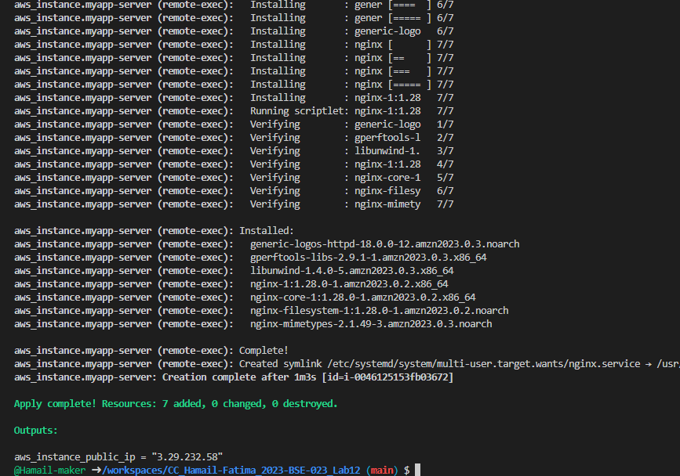

- Display the output:
terraform output
- Save screenshot as: task2_terraform_output.png — terraform output showing public IP.

- Test nginx in browser:
- Open browser and navigate to http://<public-ip>
- Save screenshot as: task2_nginx_browser.png — browser showing nginx default page.

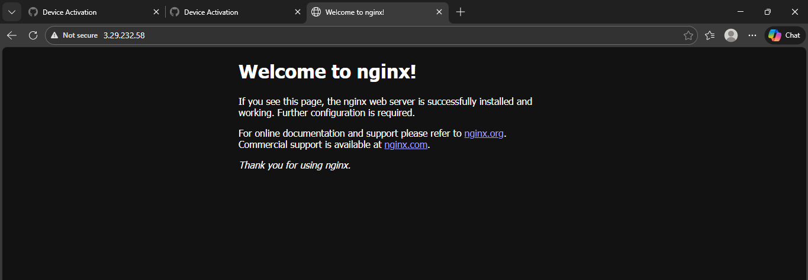

Task 3 — Use file and local-exec provisioners
In this task, you will add the file provisioner to upload the script and the local-exec provisioner to log instance information locally.
- Modify the aws_instance resource in main.tf to include all three provisioners:
resource "aws_instance" "myapp-server" {
ami = "ami-05524d6658fcf35b6"
instance_type = var.instance_type
subnet_id = aws_subnet.myapp_subnet_1.id
security_groups = [aws_default_security_group.default_sg.id]
availability_zone = var.availability_zone
associate_public_ip_address = true
key_name = aws_key_pair.ssh-key.key_name

connection {
type = "ssh"
user = "ec2-user"
private_key = file(var.private_key)
host = self.public_ip
}

provisioner "file" {
source = "./entry-script.sh"
destination = "/home/ec2-user/entry-script-on-ec2.sh"
}

provisioner "remote-exec" {
inline = [
"sudo chmod +x /home/ec2-user/entry-script-on-ec2.sh",
"sudo /home/ec2-user/entry-script-on-ec2.sh"
]
}

provisioner "local-exec" {
command = <<-EOF
echo Instance ${self.id} with public IP ${self.public_ip} has been created
EOF
}

tags = {
Name = "${var.env_prefix}-ec2-instance"
}
}
- Save screenshot as: task3_main_tf_all_provisioners.png — main.tf showing file, remote-exec, and local-exec provisioners.

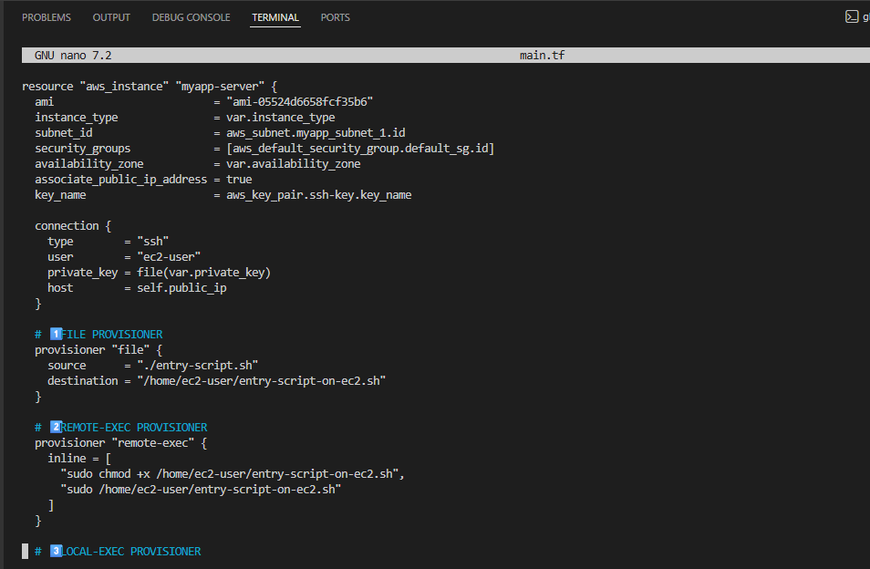

- Apply the configuration:
terraform apply -auto-approve
- Save screenshot as: task3_terraform_apply.png — terraform apply output showing all provisioners execution.

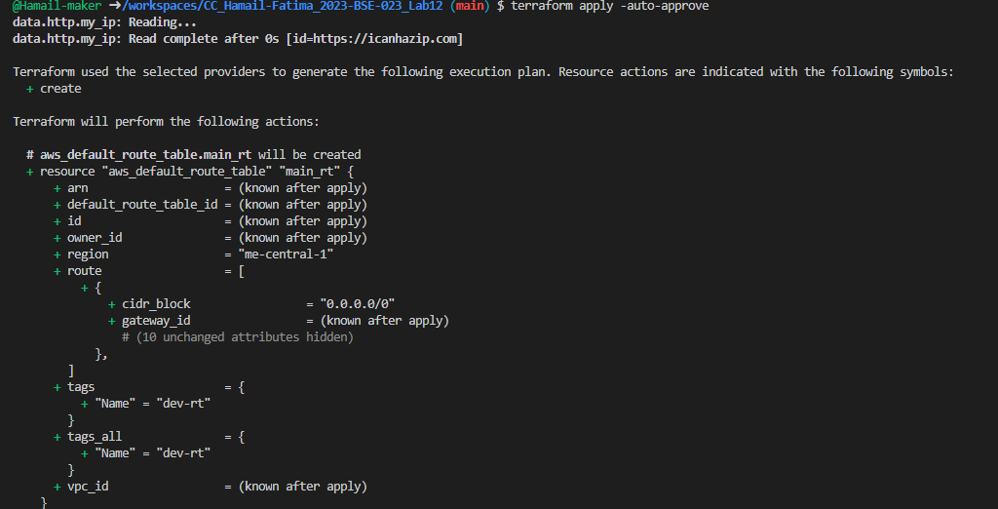

- Display the output:
terraform output
- Save screenshot as: task3_terraform_output.png — terraform output showing public IP.

- Test nginx in browser:
- Open browser and navigate to http://<public-ip>
- Save screenshot as: task3_nginx_browser.png — browser showing nginx default page.

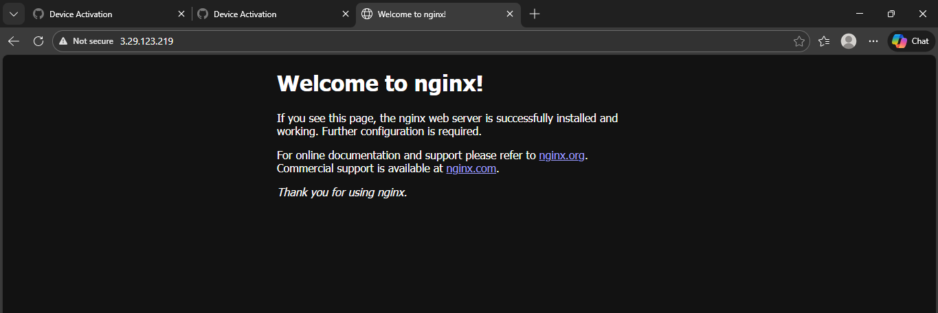

- Destroy the resources:
terraform destroy
- Type yes when prompted.
- Save screenshot as: task3_terraform_destroy.png — terraform destroy output.

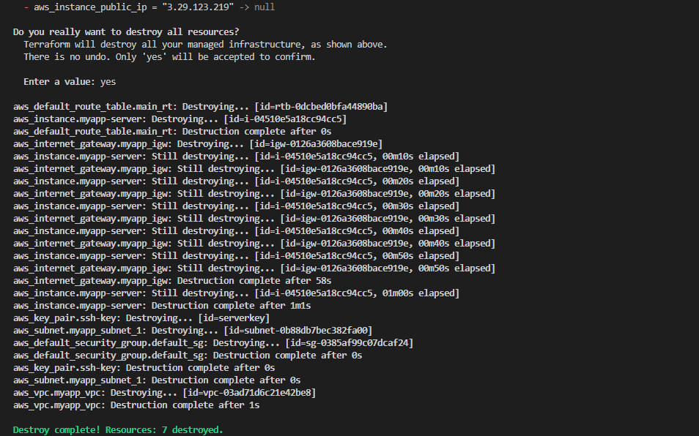

- Remove the provisioners and restore user_data:
Replace the connection and provisioner blocks with:
user_data = file("./entry-script.sh")
- Save screenshot as: task3_main_tf_restored.png — main.tf showing user_data restored.

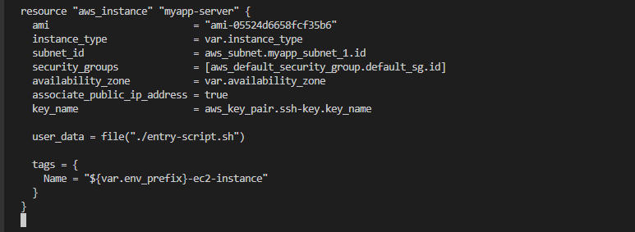

Task 4 — Create Terraform modules (subnet module)
In this task, you will create a reusable subnet module to organize your infrastructure code better.
- Create the module directory structure:
mkdir -p modules/subnet
touch modules/subnet/main.tf
touch modules/subnet/variables.tf
touch modules/subnet/outputs.tf
- Save screenshot as: task4_module_structure.png — terminal showing module directory structure (use tree or ls -R).

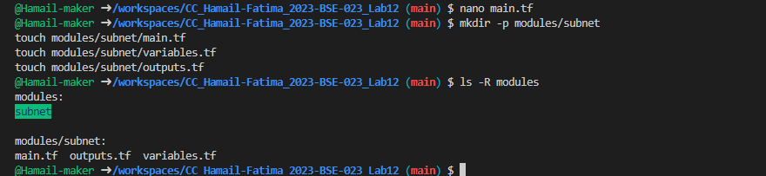

- Create modules/subnet/variables.tf:
variable "vpc_id" {}
variable "subnet_cidr_block" {}
variable "availability_zone" {}
variable "env_prefix" {}
variable "default_route_table_id" {}
- Save screenshot as: task4_subnet_variables.png — content of modules/subnet/variables.tf.

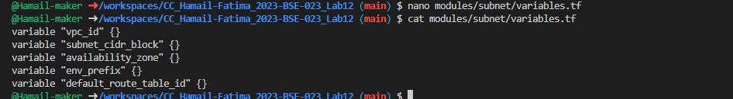

- Create modules/subnet/main.tf:
resource "aws_subnet" "myapp_subnet_1" {
vpc_id = var.vpc_id
cidr_block = var.subnet_cidr_block
availability_zone = var.availability_zone
map_public_ip_on_launch = true
tags = {
Name = "${var.env_prefix}-subnet-1"
}
}

resource "aws_default_route_table" "main_rt" {
default_route_table_id = var.default_route_table_id

route {
cidr_block = "0.0.0.0/0"
gateway_id = aws_internet_gateway.myapp_igw.id
}
tags = {
Name = "${var.env_prefix}-rt"
}
}

resource "aws_internet_gateway" "myapp_igw" {
vpc_id = var.vpc_id
tags = {
Name = "${var.env_prefix}-igw"
}
}
- Save screenshot as: task4_subnet_main.png — content of modules/subnet/main.tf.

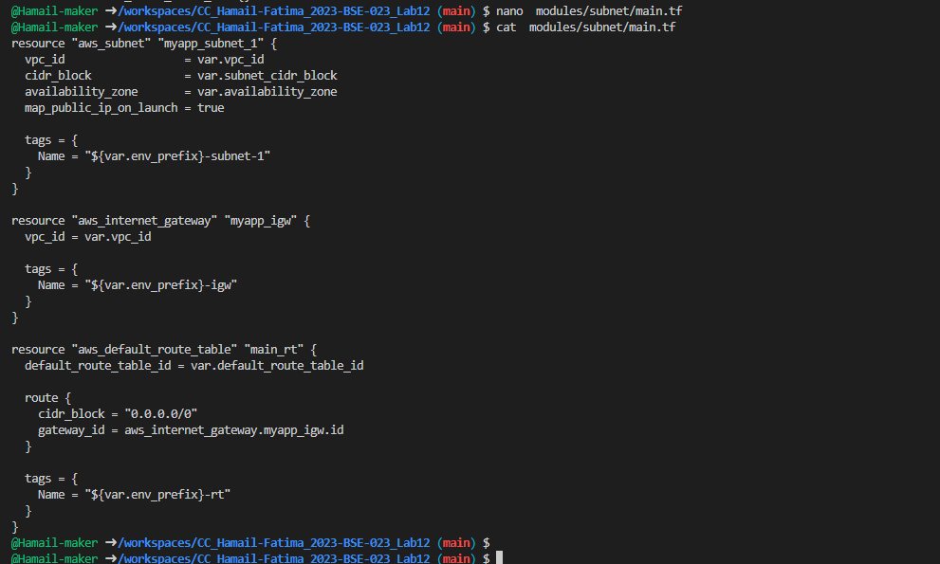

- Create modules/subnet/outputs.tf:
output "subnet" {
value = aws_subnet.myapp_subnet_1
}
- Save screenshot as: task4_subnet_outputs.png — content of modules/subnet/outputs.tf.

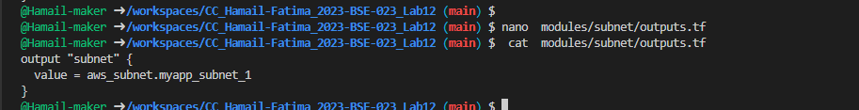

- Modify the root main.tf to use the subnet module:
Remove the subnet, route table, and internet gateway resources and replace them with:
module "myapp-subnet" {
source = "./modules/subnet"
vpc_id = aws_vpc.myapp_vpc. id
subnet_cidr_block = var.subnet_cidr_block
availability_zone = var.availability_zone
env_prefix = var.env_prefix
default_route_table_id = aws_vpc.myapp_vpc.default_route_table_id
}
And update the instance resource to reference the module output:
resource "aws_instance" "myapp-server" {
# ... other settings ...
subnet_id = module.myapp-subnet.subnet.id
# ... rest of configuration ...
}
- Save screenshot as: task4_main_tf_with_module.png — main.tf showing module usage.

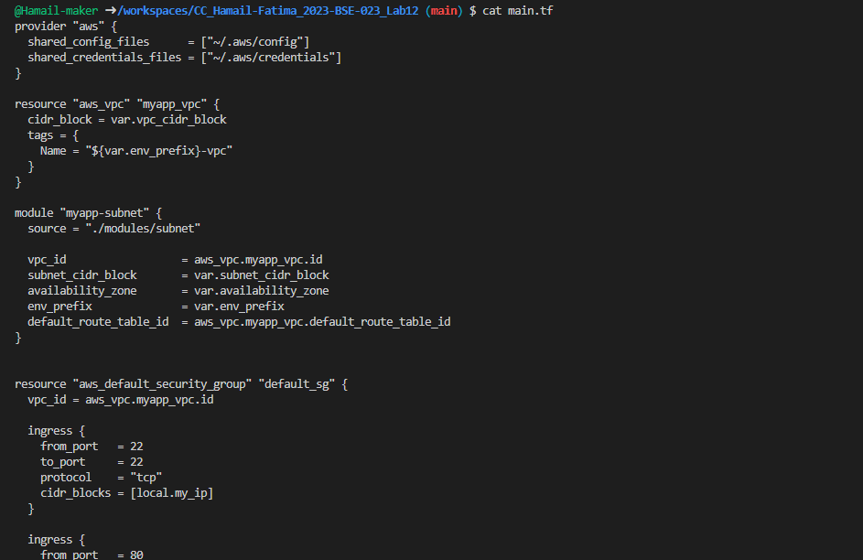

- Initialize Terraform to download the module:
terraform init
- Save screenshot as: task4_terraform_init.png — terraform init output showing module initialization.

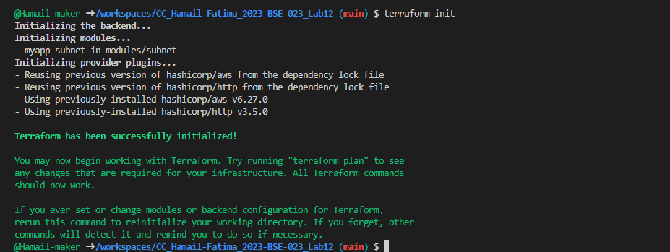

- Apply the configuration:
terraform apply -auto-approve
- Save screenshot as: task4_terraform_apply.png — terraform apply output with module.

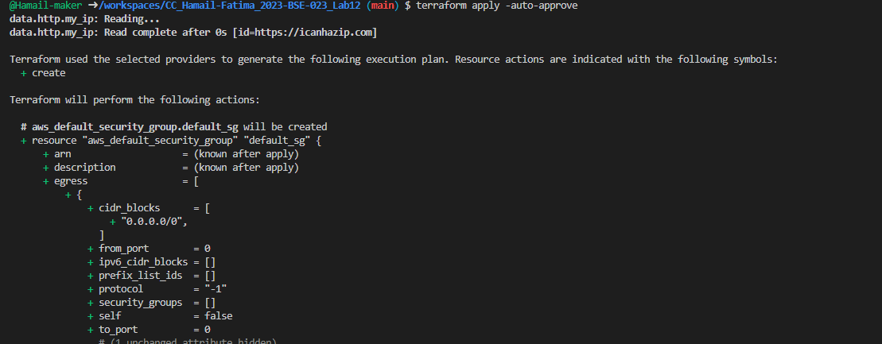

- Display the output:
terraform output
- Save screenshot as: task4_terraform_output.png — terraform output showing public IP.

- Test nginx in browser:
- Open browser and navigate to http://<public-ip>
Save screenshot as: task4_nginx_browser.png — browser showing nginx default page.

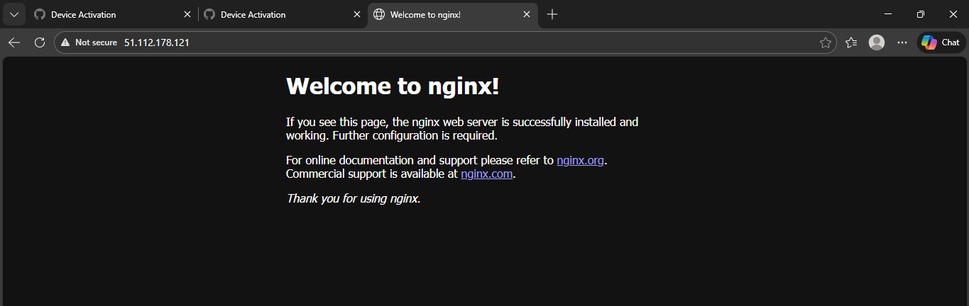

Task 5 — Create webserver module
In this task, you will create a reusable webserver module for EC2 instances.
- Create the webserver module directory structure:
mkdir -p modules/webserver
touch modules/webserver/main.tf
touch modules/webserver/variables.tf
touch modules/webserver/outputs.tf
- Save screenshot as: task5_webserver_module_structure.png — terminal showing webserver module directory.

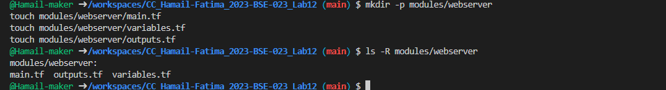

- Create modules/webserver/variables.tf:
variable "env_prefix" {}
variable "instance_type" {}
variable "availability_zone" {}
variable "public_key" {}
variable "my_ip" {}
variable "vpc_id" {}
variable "subnet_id" {}
variable "script_path" {}
variable "instance_suffix" {}
- Save screenshot as: task5_webserver_variables.png — content of modules/webserver/variables. tf.

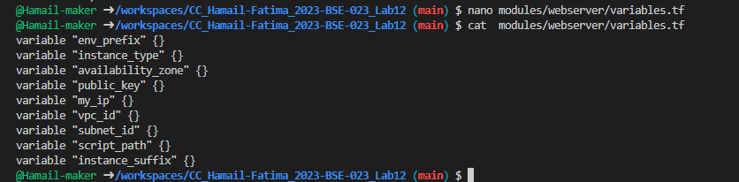

- Create modules/webserver/main.tf:
resource "aws_security_group" "web_sg" {
vpc_id = var.vpc_id
name = "${var.env_prefix}-web-sg-${var.instance_suffix}"
description = "Security group for web server allowing HTTP, HTTPS and SSH"

ingress {
from_port = 22
to_port = 22
protocol = "tcp"
cidr_blocks = [var.my_ip]
}
ingress {
from_port = 443
to_port = 443
protocol = "tcp"
cidr_blocks = ["0.0.0.0/0"]
}
ingress {
from_port = 80
to_port = 80
protocol = "tcp"
cidr_blocks = ["0.0.0.0/0"]
}
egress {
from_port = 0
to_port = 0
protocol = "-1"
cidr_blocks = ["0.0.0.0/0"]
prefix_list_ids = []
}
tags = {
Name = "${var.env_prefix}-default-sg"
}
}

resource "aws_key_pair" "ssh-key" {
key_name = "${var.env_prefix}-serverkey-${var.instance_suffix}"
public_key = file(var.public_key)
}

resource "aws_instance" "myapp-server" {
ami = "ami-05524d6658fcf35b6" # Amazon Linux 2023 Kernel 6.1 AMI
instance_type = var. instance_type
subnet_id = var.subnet_id
vpc_security_group_ids = [aws_security_group.web_sg.id]
availability_zone = var.availability_zone
associate_public_ip_address = true
key_name = aws_key_pair.ssh-key.key_name

user_data = file(var.script_path)

tags = {
Name = "${var.env_prefix}-ec2-instance-${var.instance_suffix}"
}
}
- Save screenshot as: task5_webserver_main.png — content of modules/webserver/main.tf.

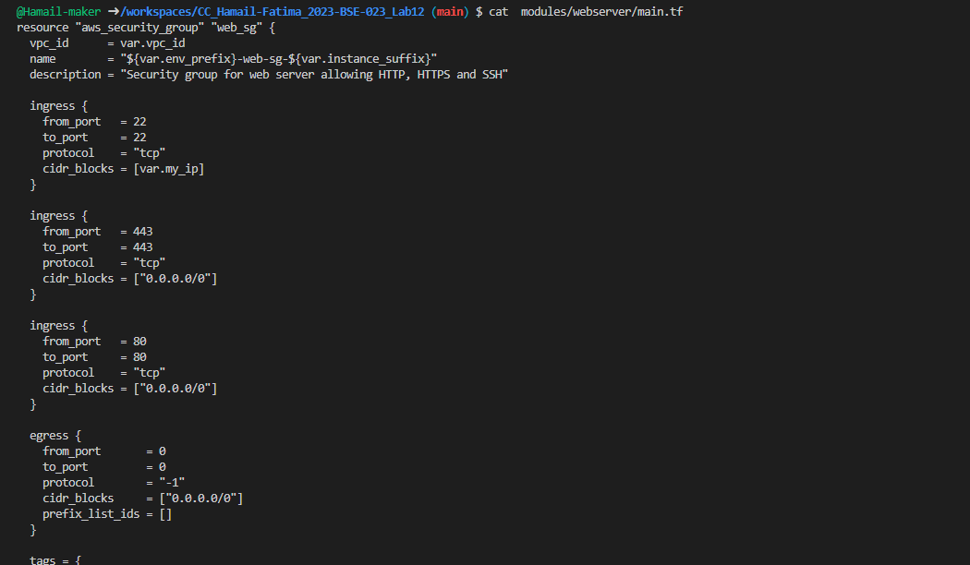

- Create modules/webserver/outputs.tf:
output "aws_instance" {
value = aws_instance.myapp-server
}

- Save screenshot as: task5_webserver_outputs.png — content of modules/webserver/outputs.tf.

- Modify the root main.tf:
Remove the security group, key pair, and instance resources. Replace them with:
module "myapp-webserver" {
source = "./modules/webserver"
env_prefix = var.env_prefix
instance_type = var. instance_type
availability_zone = var.availability_zone
public_key = var.public_key
my_ip = local.my_ip
vpc_id = aws_vpc.myapp_vpc.id
subnet_id = module.myapp-subnet.subnet.id
script_path = "./entry-script.sh"
instance_suffix = "0"
}
- Save screenshot as: task5_main_tf_webserver_module.png — main.tf showing webserver module usage.

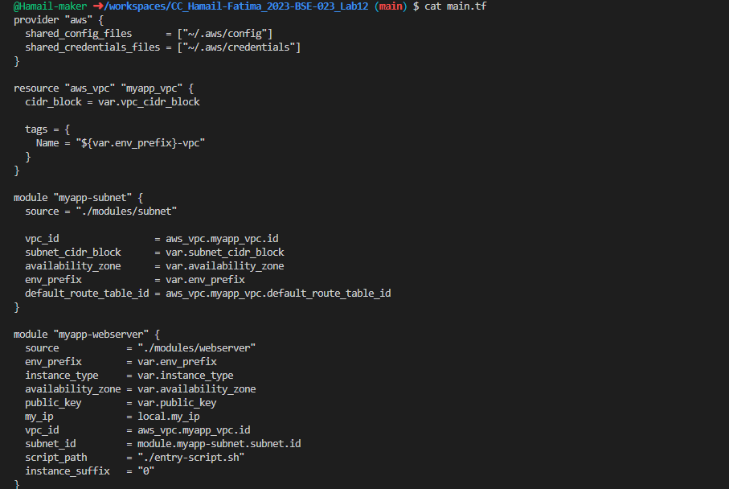

- Update outputs.tf:
output "webserver_public_ip" {
value = module.myapp-webserver.aws_instance.public_ip
}

- Save screenshot as: task5_outputs_updated.png — updated outputs.tf.

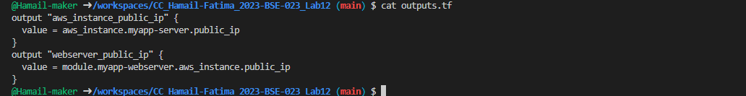

- Initialize Terraform:
terraform init
- Save screenshot as: task5_terraform_init.png — terraform init output.

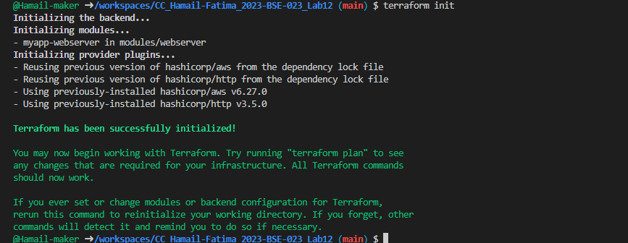

- Apply the configuration:
terraform apply -auto-approve
- Save screenshot as: task5_terraform_apply.png — terraform apply output with webserver module.

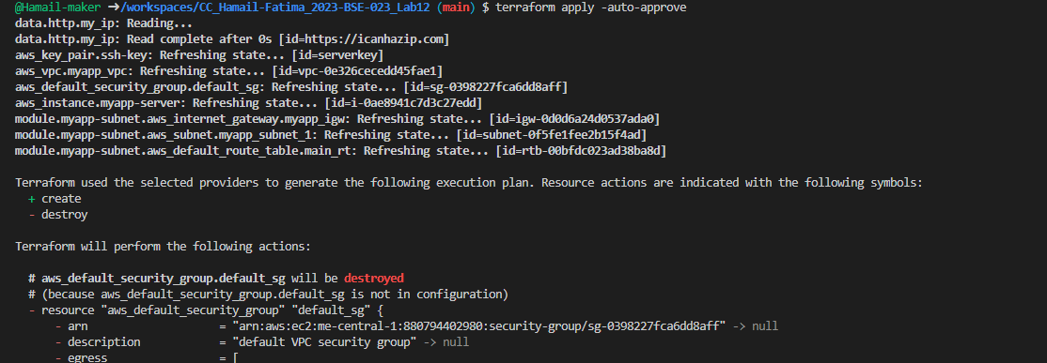

- Display the output:
terraform output
- Save screenshot as: task5_terraform_output.png — terraform output showing webserver public IP.

- Test nginx in browser:
- Open browser and navigate to http://<public-ip>
- Save screenshot as: task5_nginx_browser.png — browser showing nginx default page.

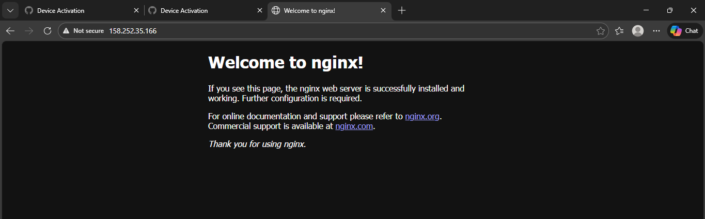

- Destroy resources:
terraform destroy
- Type yes when prompted.
- Save screenshot as: task5_terraform_destroy.png — terraform destroy output.

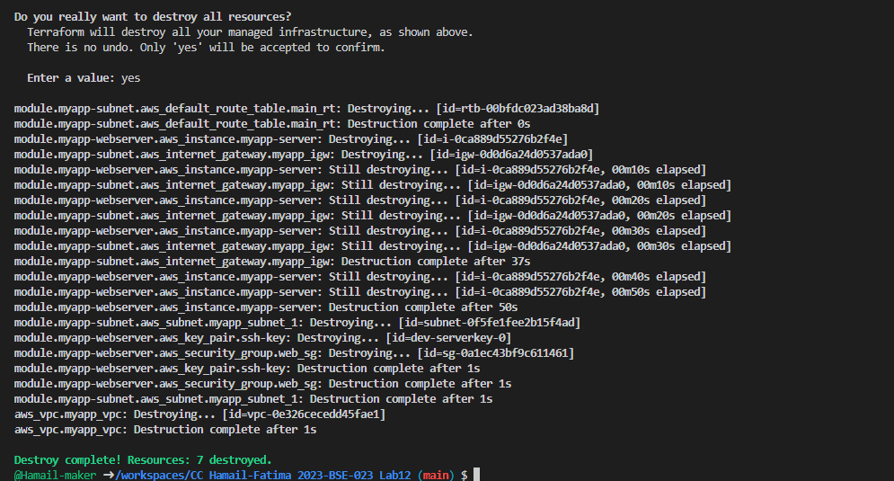

Task 6 — Configure HTTPS with self-signed certificates
In this task, you will configure Nginx to serve traffic over HTTPS using self-signed certificates.
- Update entry-script.sh with SSL configuration:
#!/bin/bash
set -e
yum update -y
yum install -y nginx
systemctl start nginx
systemctl enable nginx

# Create directories for SSL certificates if they don't exist
mkdir -p /etc/ssl/private
mkdir -p /etc/ssl/certs

# Get IMDSv2 token
TOKEN=$(curl -s -X PUT "http://169.254.169.254/latest/api/token" \
-H "X-aws-ec2-metadata-token-ttl-seconds: 21600")

# Get current public IP
PUBLIC_IP=$(curl -s -H "X-aws-ec2-metadata-token: $TOKEN" \
http://169.254.169.254/latest/meta-data/public-ipv4)

PUBLIC_HOSTNAME=$(curl -s -H "X-aws-ec2-metadata-token: $TOKEN" \
http://169.254.169.254/latest/meta-data/public-hostname)

# Generate self-signed certificate with dynamic IP
openssl req -x509 -nodes -days 365 -newkey rsa:2048 \
-keyout /etc/ssl/private/selfsigned.key \
-out /etc/ssl/certs/selfsigned.crt \
-subj "/CN=$PUBLIC_IP" \
-addext "subjectAltName=IP:$PUBLIC_IP" \
-addext "basicConstraints=CA:FALSE" \
-addext "keyUsage=digitalSignature,keyEncipherment" \
-addext "extendedKeyUsage=serverAuth"

echo "Self-signed certificate created for IP: $PUBLIC_IP"

# Backup existing nginx. conf
cp /etc/nginx/nginx.conf /etc/nginx/nginx.conf.bak

# Overwrite nginx.conf with the desired content
cat <<EOF > /etc/nginx/nginx.conf
user nginx;
worker_processes auto;
error_log /var/log/nginx/error.log notice;
pid /run/nginx. pid;

events {
worker_connections 1024;
}

http {
log_format main '\$remote_addr - \$remote_user [\$time_local] "\$request"'
'\$status \$body_bytes_sent "\$http_referer"'
'"\$http_user_agent" "\$http_x_forwarded_for"';

access_log /var/log/nginx/access.log main;

sendfile on;
tcp_nopush on;
keepalive_timeout 65;
types_hash_max_size 4096;

include /etc/nginx/mime.types;
default_type application/octet-stream;

upstream backend_servers {
server 158.252.94.241:80;
server 158.252.94.242:80 backup;
}

server {
listen 443 ssl;
server_name $PUBLIC_IP;
ssl_certificate /etc/ssl/certs/selfsigned.crt;
ssl_certificate_key /etc/ssl/private/selfsigned.key;

location / {
root /usr/share/nginx/html;
index index.html;
# proxy_pass http://158.252.94.241:80;
# proxy_pass http://backend_servers;

}
}

server {
listen 80;
server_name _;
return 301 https://\$host\$request_uri;
}
}
EOF

# Test and restart Nginx
systemctl restart nginx
- Save screenshot as: task6_entry_script_https.png — updated entry-script.sh with HTTPS configuration.

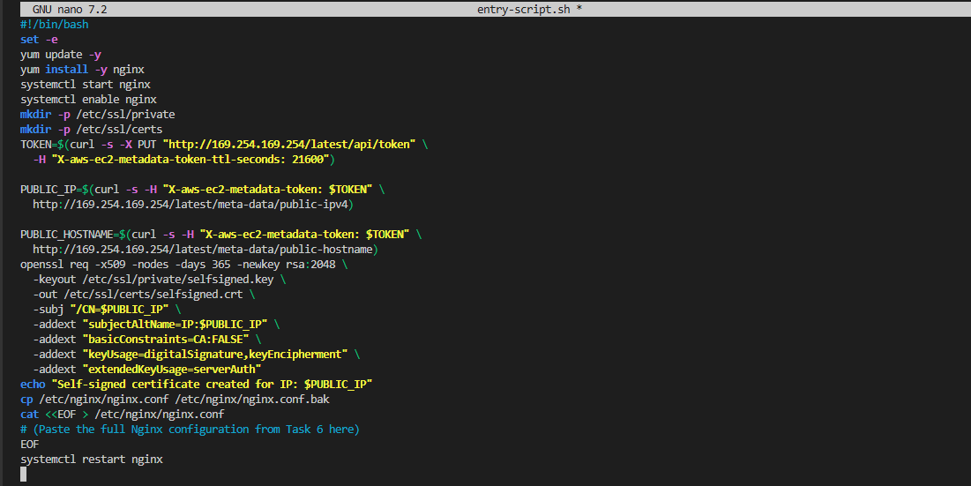
- Apply the configuration:
terraform apply -auto-approve
- Save screenshot as: task6_terraform_apply.png — terraform apply output.

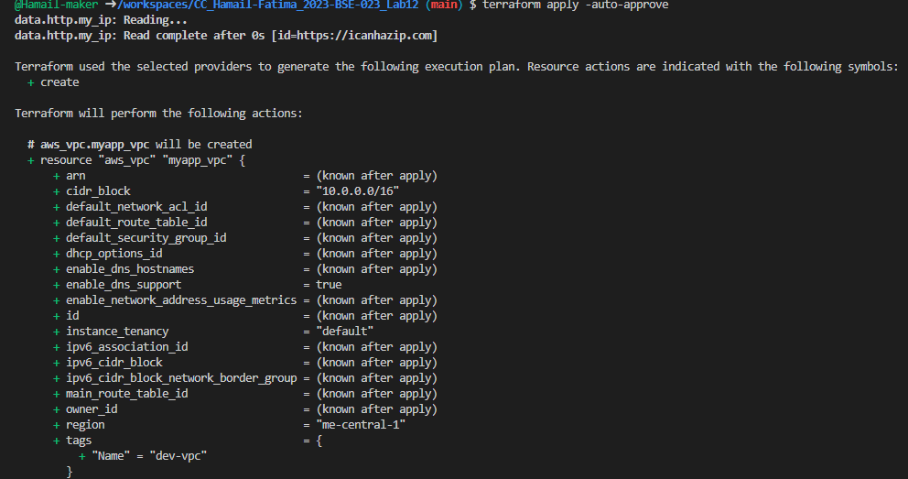

- Display the output:
terraform output
- Save screenshot as: task6_terraform_output.png — terraform output showing public IP.

- Test HTTPS in browser:
- Open browser and navigate to https://<public-ip>
- You will see a warning: "Warning: Potential Security Risk Ahead"
- Click "Advanced" button
- Click "Accept the Risk and Continue"
- Save screenshot as: task6_browser_security_warning.png — browser showing security warning.

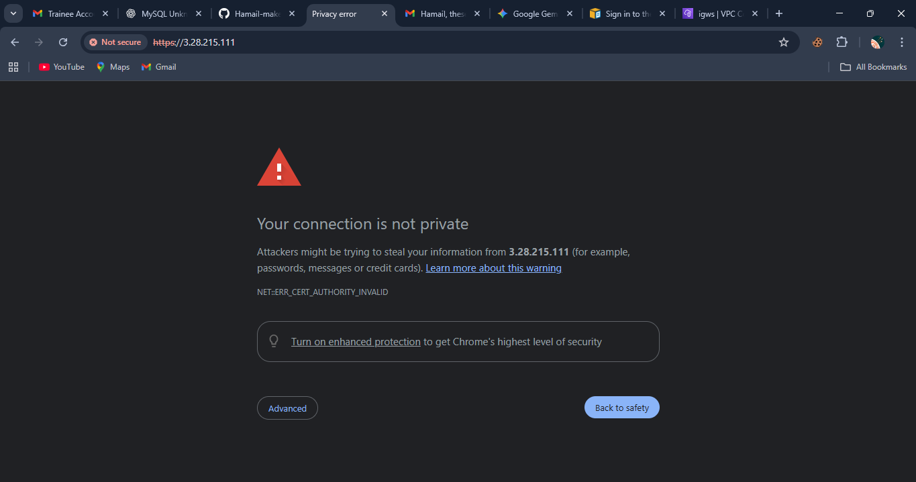

- Save screenshot as: task6_nginx_https_browser.png — browser showing nginx page over HTTPS after accepting risk.

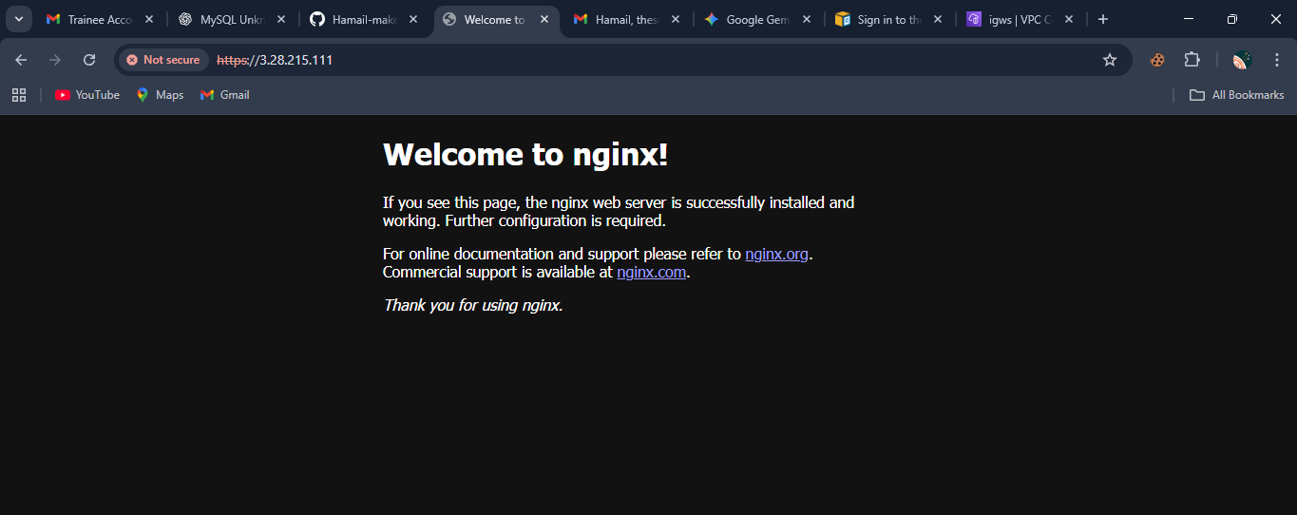

- Verify HTTP to HTTPS redirect:
- Open browser and navigate to http://<public-ip>
- Verify it redirects to https://<public-ip>
- Save screenshot as: task6_http_redirect.png — browser showing redirect from HTTP to HTTPS.

Task 7 — Configure Nginx as reverse proxy
In this task, you will create a backend web server and configure Nginx to act as a reverse proxy.
- Create apache.sh script for backend web server:
#!/bin/bash
yum update -y
yum install httpd -y
systemctl start httpd
systemctl enable httpd
echo "<h1>Welcome to My Web Server</h1>" > /var/www/html/index.html
hostnamectl set-hostname myapp-webserver
echo "<h2>Hostname: $(hostname)</h2>" >> /var/www/html/index.html
TOKEN=$(curl -s -X PUT "http://169.254.169.254/latest/api/token" \
-H "X-aws-ec2-metadata-token-ttl-seconds: 21600")
echo "<h2>Private IP: $(curl -s -H "X-aws-ec2-metadata-token: $TOKEN" http://169.254.169.254/latest/meta-data/local-ipv4)</h2>" >> /var/www/html/index.html
echo "<h2>Public IP: $(curl -s -H "X-aws-ec2-metadata-token: $TOKEN" http://169.254.169.254/latest/meta-data/public-ipv4)</h2>" >> /var/www/html/index.html
echo "<h2>Public DNS: $(curl -s -H "X-aws-ec2-metadata-token: $TOKEN" http://169.254.169.254/latest/meta-data/public-hostname)</h2>" >> /var/www/html/index.html
echo "<h2>Deployed via Terraform</h2>" >> /var/www/html/index. Html

- Save screenshot as: task7_apache_script.png — content of apache.sh file.

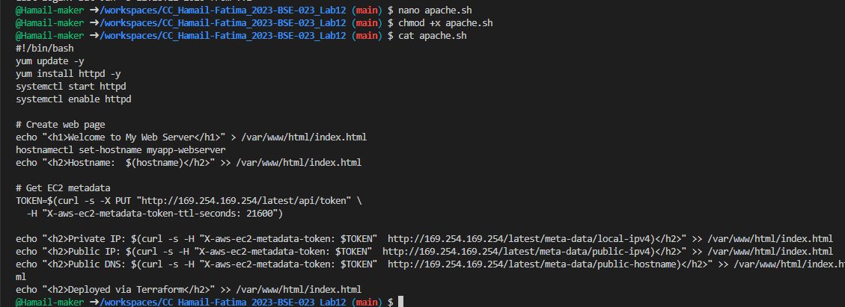

- Add the backend web server module to main.tf:
module "myapp-web-1" {
source = "./modules/webserver"
env_prefix = var.env_prefix
instance_type = var.instance_type
availability_zone = var.availability_zone
public_key = var.public_key
my_ip = local.my_ip
vpc_id = aws_vpc. myapp_vpc.id
subnet_id = module.myapp-subnet.subnet.id
script_path = "./apache.sh"
instance_suffix = "1"
}
- Save screenshot as: task7_main_tf_web1.png — main. tf showing myapp-web-1 module.

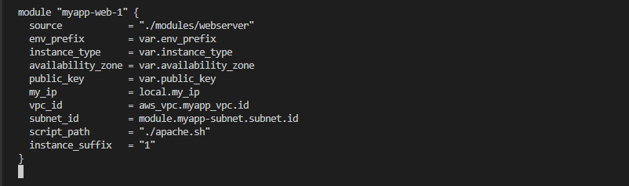

- Update outputs.tf:
output "aws_web-1_public_ip" {
value = module.myapp-web-1.aws_instance.public_ip
}
- Save screenshot as: task7_outputs_web1.png — outputs.tf with web-1 output.

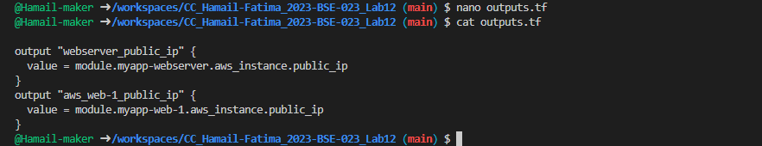

- Apply the configuration:
terraform apply -auto-approve
- Save screenshot as: task7_terraform_apply.png — terraform apply output showing both instances created.

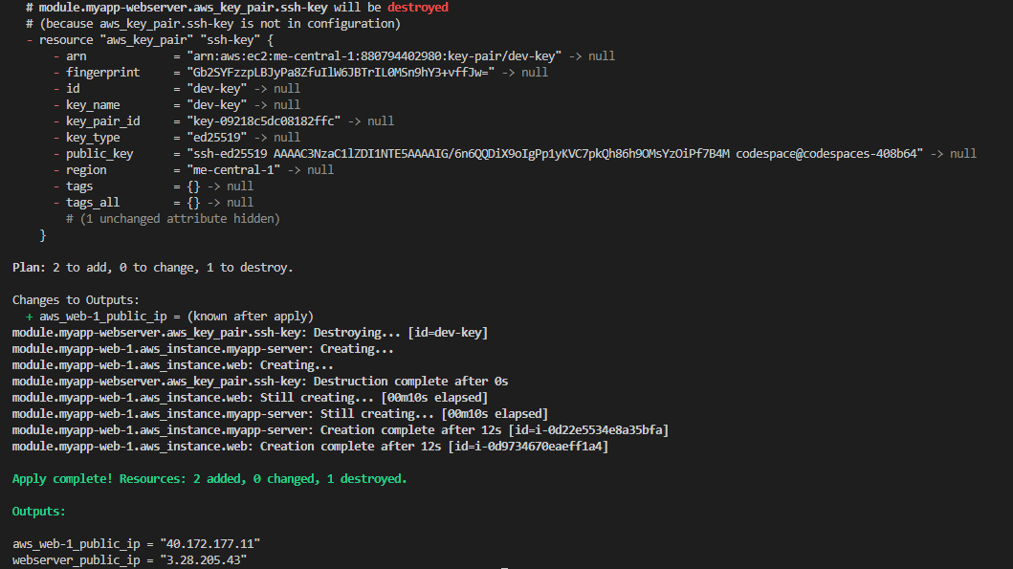

- Get the outputs:
terraform output
- Save screenshot as: task7_terraform_output.png — showing both public IPs.

- SSH into the webserver (Nginx proxy server):
ssh ec2-user@<webserver-public-ip>
- Save screenshot as: task7_ssh_webserver. png — SSH session to webserver.

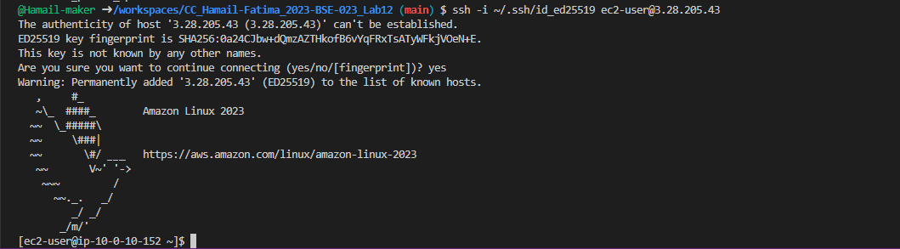

- Edit the Nginx configuration:
sudo vim /etc/nginx/nginx.conf
Modify the location block to proxy to web-1:
location / {
# root /usr/share/nginx/html;
# index index. html;
proxy_pass http://<web-1-public-ip>:80;
# proxy_pass http://backend_servers;

}
- Save screenshot as: task7_nginx_conf_reverse_proxy.png — nginx.conf showing proxy_pass configuration.

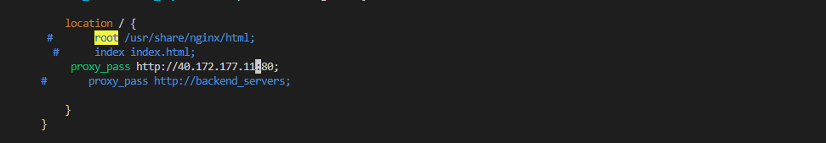

- Restart Nginx:
sudo systemctl restart nginx
- Save screenshot as: task7_nginx_restart.png — terminal showing nginx restart command.

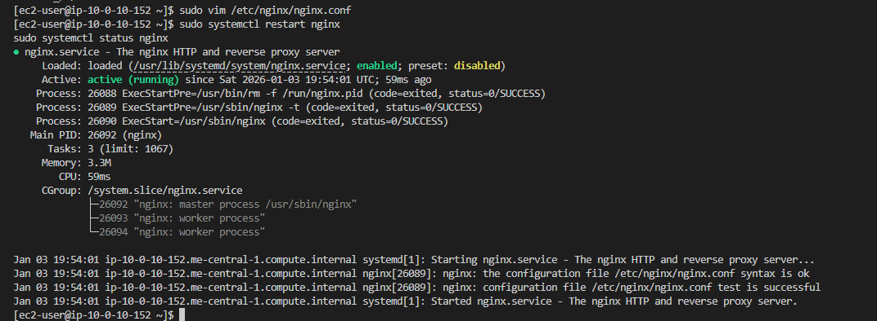

- View Nginx logs and configuration files:
cat /var/log/nginx/error.log
- Save screenshot as: task7_error_log.png — content of error. log.

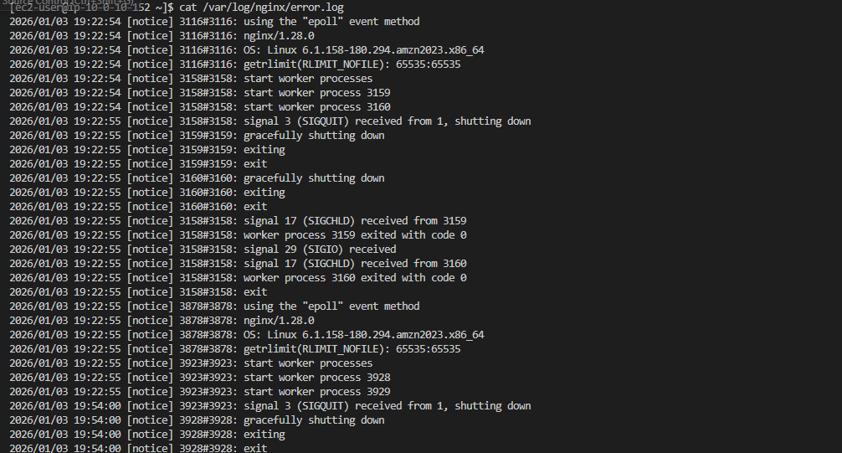

cat /var/log/nginx/access.log
- Save screenshot as: task7_access_log.png — content of access.log.

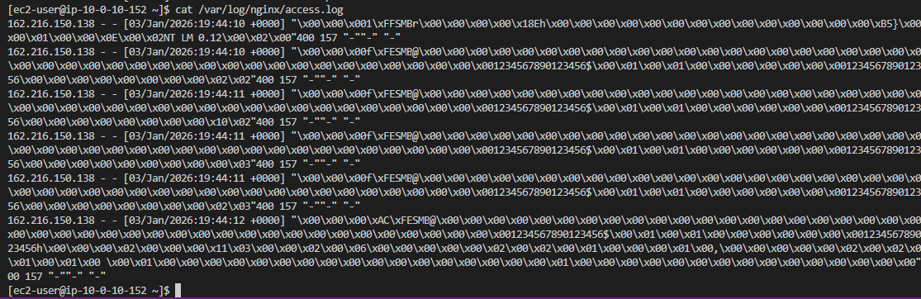

cat /etc/nginx/mime.types
- Save screenshot as: task7_mime_types.png — content of mime.types.

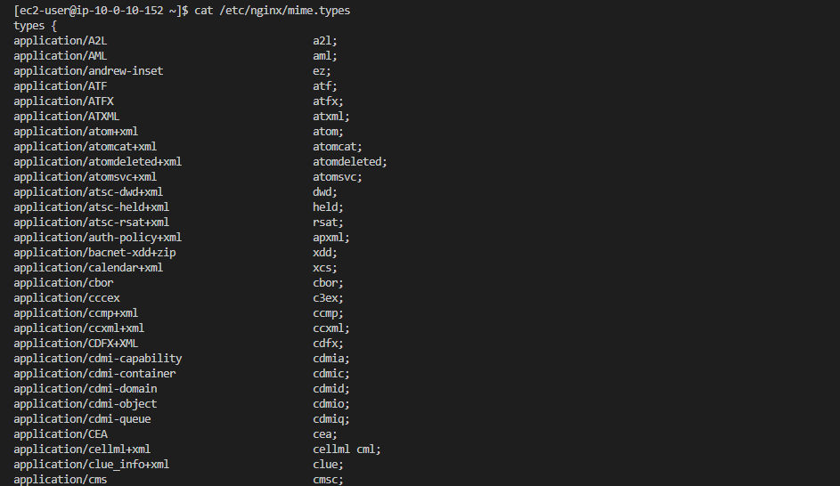

cat /etc/ssl/certs/selfsigned.crt
- Save screenshot as: task7_ssl_cert.png — content of selfsigned.crt.

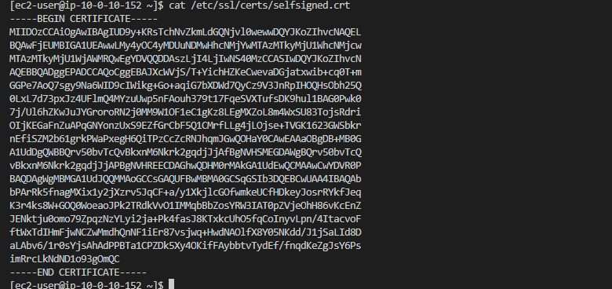

sudo cat /etc/ssl/private/selfsigned.key
- Save screenshot as: task7_ssl_key.png — content of selfsigned.key.

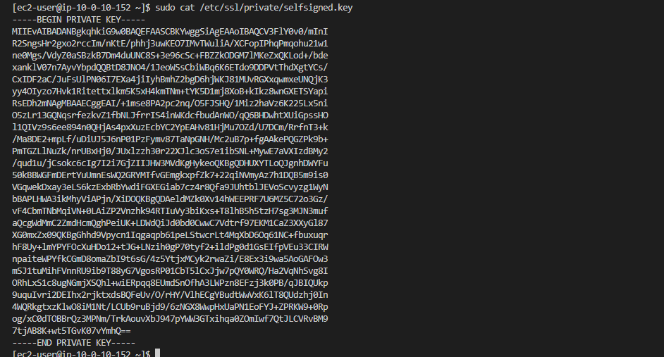

- Test reverse proxy in browser:
- Open browser and navigate to https://<webserver-public-ip>

- You should see the web-1 Apache page through the Nginx proxy
- Save screenshot as: task7_reverse_proxy_browser.png — browser showing web-1 content through proxy.

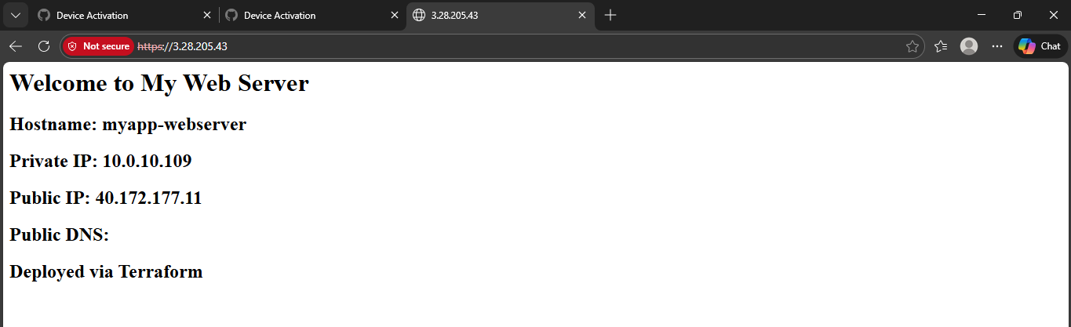

Task 8 — Configure Nginx as load balancer
In this task, you will add a second backend server and configure Nginx to load balance between them.
- Add the second web server module to main.tf:
module "myapp-web-2" {
source = "./modules/webserver"
env_prefix = var.env_prefix
instance_type = var.instance_type
availability_zone = var. availability_zone
public_key = var.public_key
my_ip = local.my_ip
vpc_id = aws_vpc.myapp_vpc.id
subnet_id = module.myapp-subnet.subnet.id
script_path = "./apache.sh"
instance_suffix = "2"
}
- Save screenshot as: task8_main_tf_web2.png — main.tf showing myapp-web-2 module.

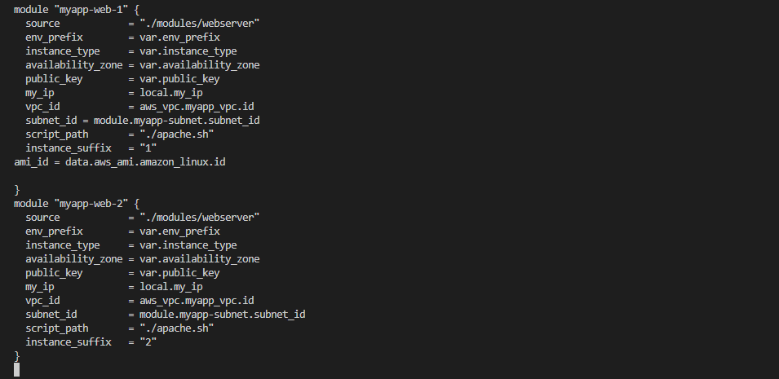

- Update outputs.tf:
output "aws_web-2_public_ip" {
value = module. myapp-web-2.aws_instance.public_ip
}
- Save screenshot as: task8_outputs_web2.png — outputs.tf with web-2 output.

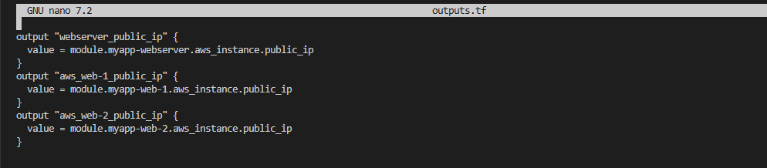

- Apply the configuration:
terraform apply -auto-approve
- Save screenshot as: task8_terraform_apply.png — terraform apply output showing web-2 created.

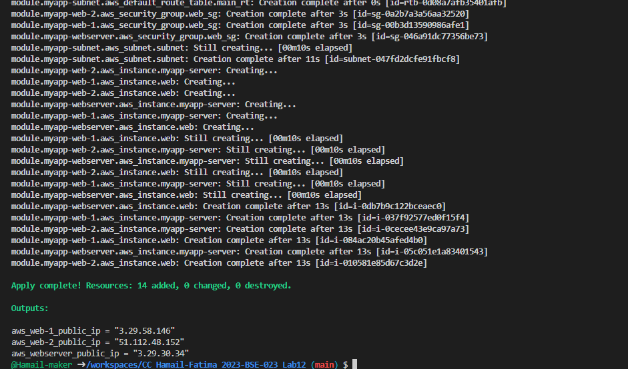

- Get all outputs:
terraform output
- Save screenshot as: task8_terraform_output.png — showing all three public IPs.

- SSH into the webserver (Nginx proxy):
ssh ec2-user@<webserver-public-ip>
- Edit Nginx configuration for load balancing:
sudo vim /etc/nginx/nginx.conf
Update the upstream block and location:
upstream backend_servers {
server <web-1-public-ip>:80;
server <web-2-public-ip>:80;
}

# ... in server block:
location / {
# root /usr/share/nginx/html;
# index index.html;
# proxy_pass http://<web-1-public-ip>:80;
proxy_pass http://backend_servers;

}
- Save screenshot as: task8_nginx_conf_load_balancer.png — nginx.conf showing load balancing configuration.

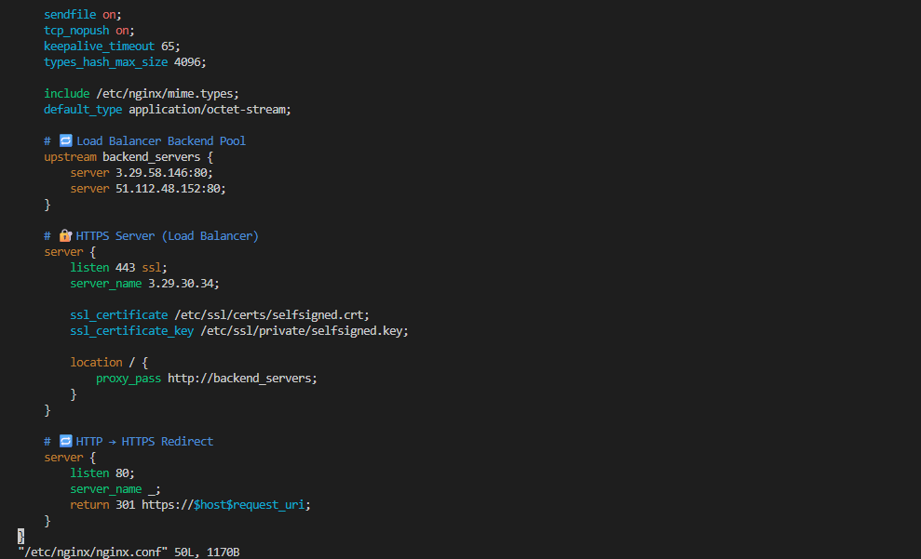
- Restart Nginx:
sudo systemctl restart nginx
- Save screenshot as: task8_nginx_restart.png — terminal showing nginx restart.

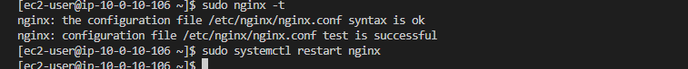

- Test load balancing in browser:
- Open browser and navigate to https://<webserver-public-ip>
- Reload the page multiple times
- You should see the content alternating between web-1 and web-2 (check the hostname/IP in the page)
- Save screenshot as: task8_load_balancer_web1.png — browser showing web-1 content.

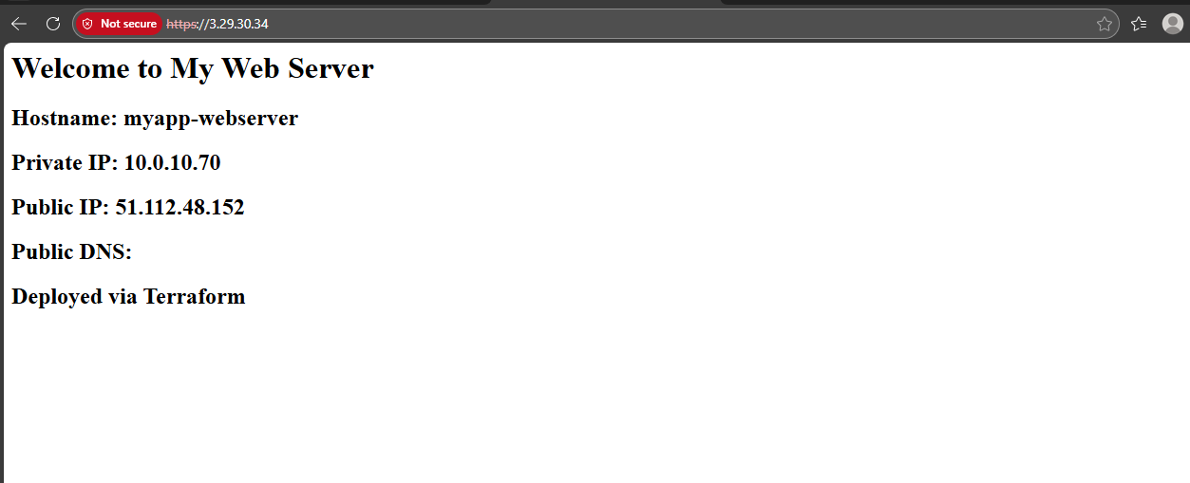

- Save screenshot as: task8_load_balancer_web2.png — browser showing web-2 content after reload.

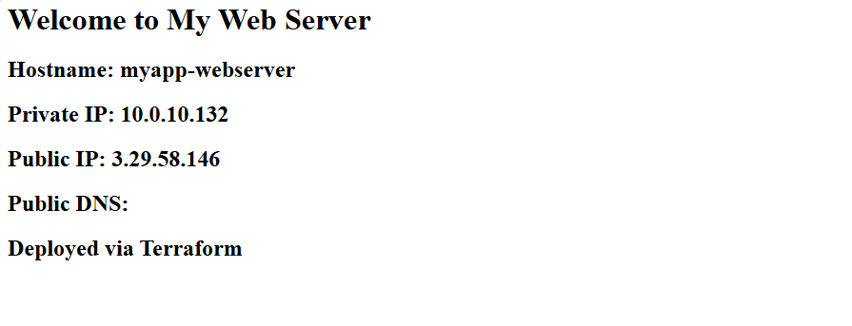

Task 9 — Configure high availability with backup servers
In this task, you will configure one server as primary and another as backup for high availability.
- SSH into the webserver:
ssh ec2-user@<webserver-public-ip>
- Edit Nginx configuration for high availability:
sudo vim /etc/nginx/nginx.conf
Update the upstream block to make web-2 a backup:
upstream backend_servers {
server <web-1-public-ip>:80;
server <web-2-public-ip>:80 backup;
}
- Save screenshot as: task9_nginx_conf_ha_web1_primary.png — nginx.conf with web-2 as backup.

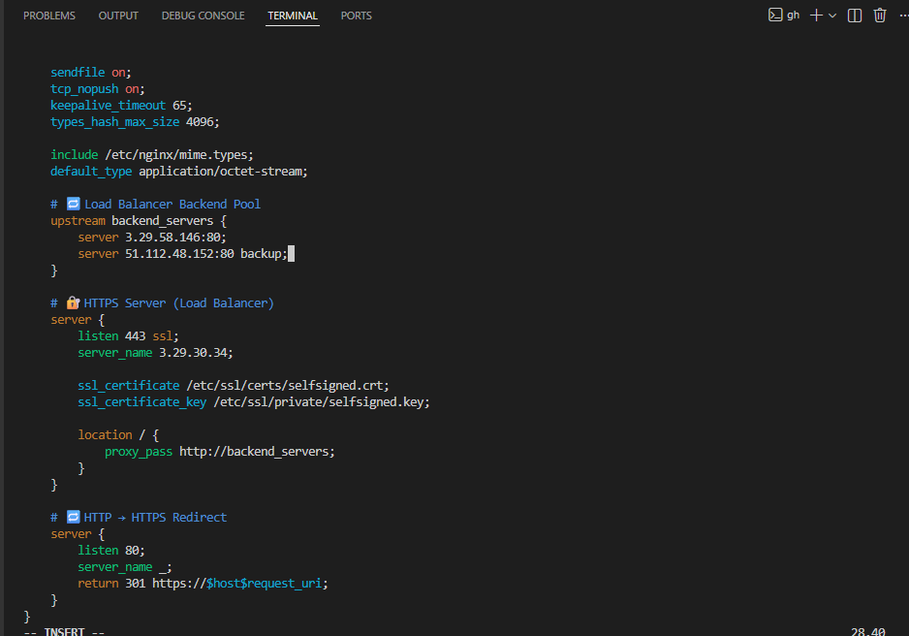

- Restart Nginx:
sudo systemctl restart nginx
- Test in browser:
- Open browser and navigate to https://<webserver-public-ip>
- Reload multiple times
- You should ONLY see web-1 (primary server)
- Save screenshot as: task9_ha_web1_only.png — browser showing only web-1 content on multiple reloads.

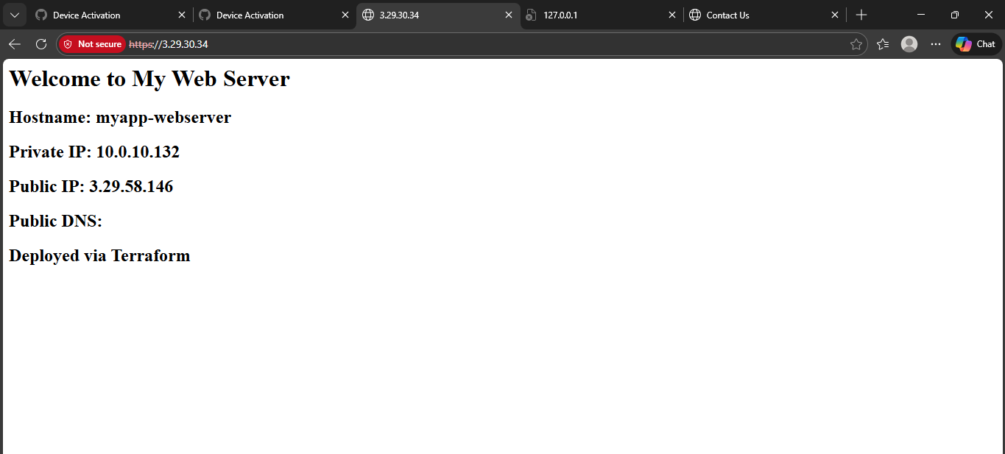

- Switch backup configuration:
sudo vim /etc/nginx/nginx.conf
Update to make web-1 backup:
upstream backend_servers {
server <web-1-public-ip>:80 backup;
server <web-2-public-ip>:80;
}
- Save screenshot as: task9_nginx_conf_ha_web2_primary.png — nginx.conf with web-1 as backup.

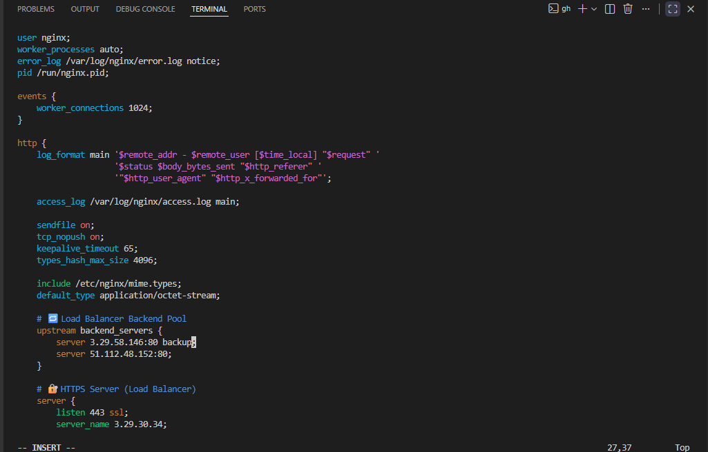

- Restart Nginx:
sudo systemctl restart nginx
- Test in browser:
- Reload multiple times
- You should ONLY see web-2 (now the primary server)
- Save screenshot as: task9_ha_web2_only.png — browser showing only web-2 content on multiple reloads.

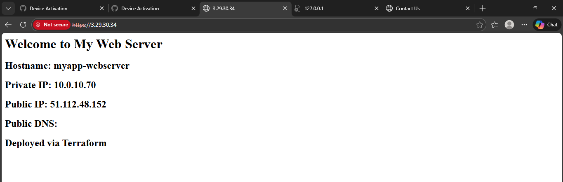

Task 10

In this task, you will enable caching in Nginx to improve performance.
- SSH into the webserver:
ssh ec2-user@<webserver-public-ip>
- Edit Nginx configuration to enable caching:
sudo vim /etc/nginx/nginx.conf
Add proxy cache configuration in the http block and location block:
http {
proxy_cache_path /var/cache/nginx levels=1:2 keys_zone=my_cache:10m inactive=60m max_size=1g;

log_format main '\$remote_addr - \$remote_user [\$time_local] "\$request" '
'\$status \$body_bytes_sent "\$http_referer" '
'"\$http_user_agent" "\$http_x_forwarded_for"';

# ... other settings ...

upstream backend_servers {
server <web-1-public-ip>:80;
server <web-2-public-ip>:80;
}

server {
listen 443 ssl;
server_name $PUBLIC_IP;
ssl_certificate /etc/ssl/certs/selfsigned.crt;
ssl_certificate_key /etc/ssl/private/selfsigned.key;

location / {
# root /usr/share/nginx/html;
# index index.html;
# proxy_pass http://<web-1-public-ip>:80;
proxy_pass http://backend_servers;
proxy_cache my_cache;
proxy_cache_valid 200 60m;
proxy_cache_key "$scheme$request_uri";
add_header X-Cache-Status $upstream_cache_status;
}
}

# ... rest of config ...
}
- Save screenshot as: task10_nginx_conf_cache.png — nginx.conf showing cache configuration.

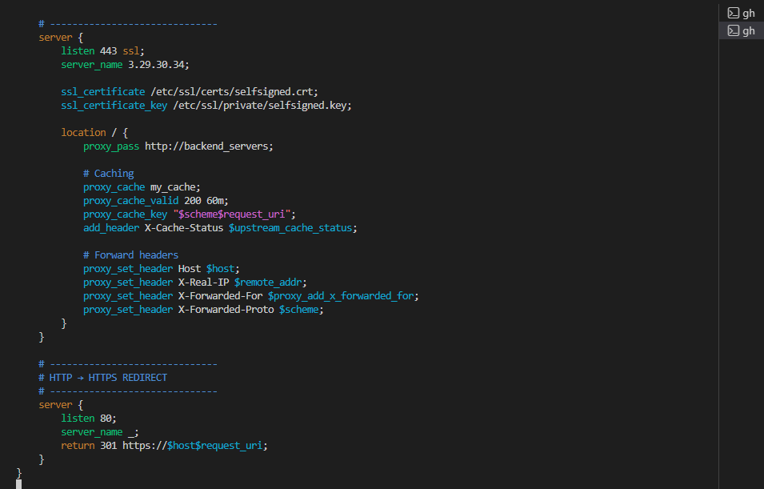

- Restart Nginx:
sudo systemctl restart nginx
- Save screenshot as: task10_nginx_restart.png — terminal showing nginx restart.

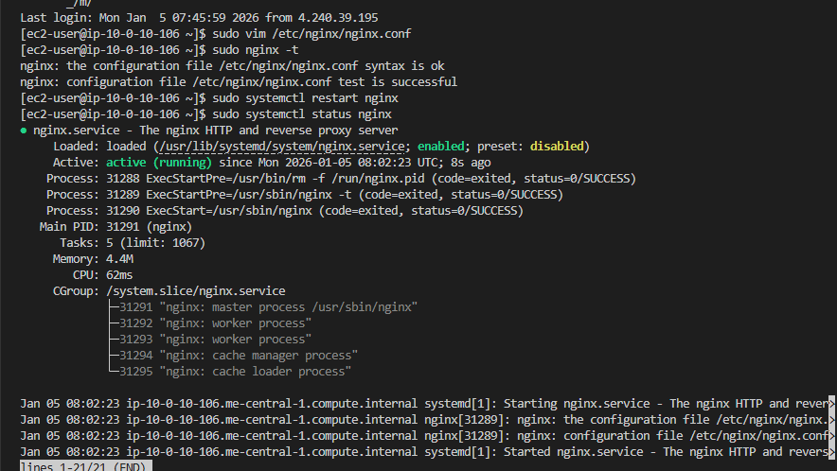

- Test caching in browser:
- Open browser developer tools (F12)
- Navigate to Network tab
- Visit https://<webserver-public-ip>
- Check response headers for X-Cache-Status
- First request should show MISS
- Reload the page
- Second request should show HIT
- Save screenshot as: task10_cache_miss.png — browser dev tools showing X-Cache-Status: MISS on first request.

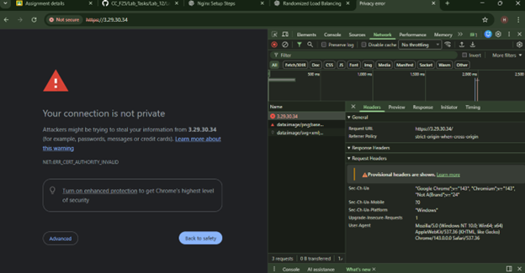

- Save screenshot as: task10_cache_hit.png — browser dev tools showing X-Cache-Status: HIT on subsequent request.

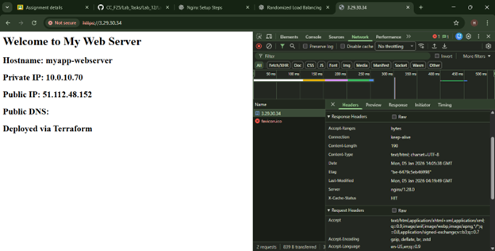

- Verify cache directory:
ls -la /var/cache/nginx/
- Save screenshot as: task10_cache_directory.png — terminal showing cache directory contents.

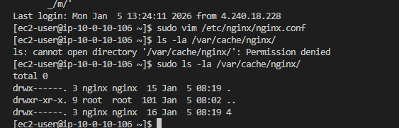

Cleanup
- Exit SSH session:
exit
- Destroy all resources:
terraform destroy
- Type yes when prompted for confirmation.
- Save screenshot as: cleanup_destroy_prompt.png — terminal showing terraform destroy prompt.

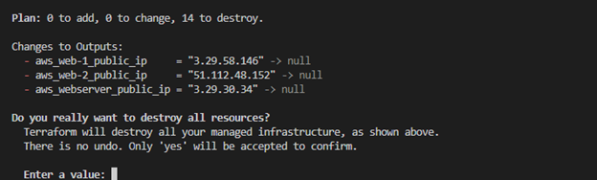

- Save screenshot as: cleanup_destroy_complete.png — terraform destroy completion output.

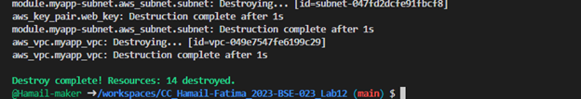

- Verify state files:
cat terraform.tfstate
- Save screenshot as: cleanup_state_empty.png — showing empty terraform. tfstate.

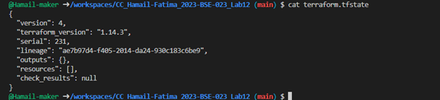

- List all project files:
tree
# or
ls -la
- Save screenshot as: cleanup_final_files.png — showing final project structure.

